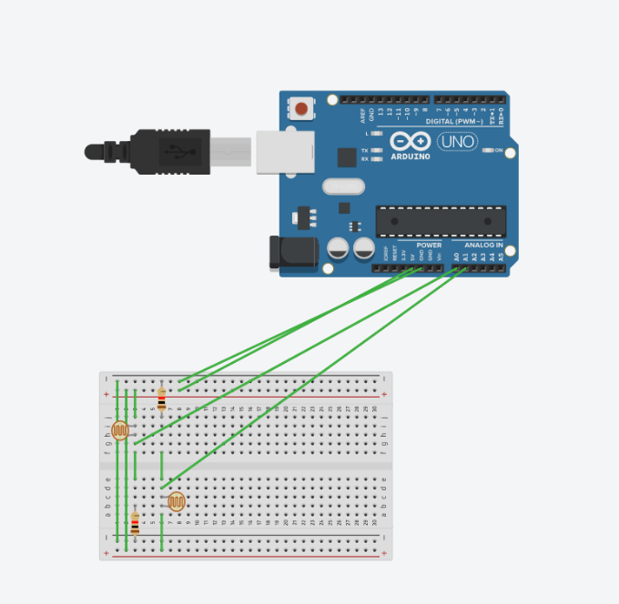

**Aim: Design a visitor counting system with the help of LDR for a hall. Assume that only one person can pass through the door at any time and also there are separate entry and exit door.**

**Concept Used:**

When a person will obstruct the light to LDR, LDR will count it and will add or deduct as per the instructions given to the Arduino.

**Observation:**

When a person comes near the LDR sensor the LDR will add 1 to the serial monitor and also when LDR at exit will sense someone it will deduct 1.

**Precaution:**

1. Connection must be made carefully with the breadboard and Arduino.
2. Wire should be connected to the pin which is defined in the program.
3. Code should be in case sensitive form.
4. While making connections connection of the breadboard should be kept in mind.

**Learning Outcome:**

1. Application of LDR and Ultrasonic sensor in everyday life.
2. We get better understanding of Arduino and its components.
3. We get some skills to use various sensor along with Arduino.